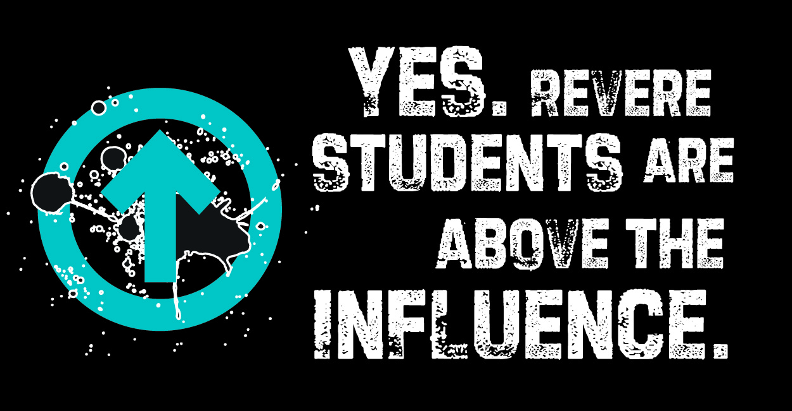

Revere CARES Coalition

Alcohol, Tobacco, and Other Drug (ATOD) Prevention Initiative

Mini-Grant Application
Mini Grant Goal:
Our goal for the mini grants is to provide community members an opportunity to apply for funds for activities, programs or projects to help young people make positive decisions for themselves, especially around not using drugs and alcohol. Schools, teachers, councilors, students, organizations, neighborhood groups and others are welcomed to apply.

We are looking to fund the following:

- Mental Health Opportunities: Students face many pressures on a daily basis and there is a connection between mental health and substance use. Propose ideas that help students manage their mental well being, or improve their skills at managing pressure and stress. Ideas could include: workshops on stress management, a peer-to-peer counseling group, physical activities for mental health or other creative ideas.

- Above the Influence Activities or Art Project: The coalition has adopted the national Above the Influence campaign for Revere. This campaign helps young people think about the positive and negative influences in their lives and encourages them to make good decisions for themselves, especially around not using drugs and alcohol. Over the years the coalition has implemented different campaign activities. Now you can too! We are looking for teachers, club leaders, or any other groups working with youth to implement activities from the Above Influence Campaign Toolkit. Examples include:

  - What is Stressing You Out?: An activity to help youth reflect on what causes stress in their life and create a plan to manage it.
  - Not Prescribed: An active that address teen medicine abuse.
  - Express it: an activity that calls on teens to create a short skit, song or dance that educates and inspires them and their peers to live Above the Influence.
Other suggested ATI activities include:
  - Other art project: If you are working with a group of artistic youth, you can propose a project to be displayed in the community.
  - Community Walk for Recovery/Above the Influence Walk: September is National Recovery Month. This observance raises awareness of addiction and mental health services that enable those with a mental and/or substance use disorder to live a healthy and rewarding life. In years past, the ATOD task force has combined this message with the Above the Influence message to engage over 300 students in a rally and walk to show that they want to be above the influence. This year, we would like to see the community take on this inspiring event and possibly make it their own.

Download the Above the Influence toolkit to view all the activities you can implement: http://partners.atipartnerships.com/downloads-toolkits/

- Positive Alternative Activities: Propose an idea for positive alternative activities that will keep youth engaged in a healthy manner. This can be a club or an ongoing activity. Using The Above the Influence message is strongly encouraged, but not required if there is a clear tie to substance use prevention or mental health improvement.

- Innovative idea!: Do you have an idea about a program, project or activity to engaged young people in a positive manner? Will this idea also encourage them to make good decisions for themselves especially around not using drugs and alcohol? Then this is your chance to apply for funds.

Timeline:
Applications are due Sunday, January 17th, 2015 at 5pm.
You can expect to hear back on your application by February 1, 2015.

Available funds:
- In this round, we will be awarding up to $10,000 dollars.
- You may apply for any amount between $1 to $10,000 dollars as long as the amount is justified. The amount may be negotiated or adjusted by the review committee.
- The ATOD task force reviews all proposals, considers the total amount requested, impact, and other proposal and will try to fund as many ideas as possible.

Let us help you:
If you are interested in applying for a mini grant, you may schedule an appointment with the ATOD Task Force manager to review your idea and receive assistance filling out your application. Contact information is provided at the end of this document.

Evaluation Criteria:
The Mini Grant applications will be evaluated on the following criteria:

- Level of impact (School/ City/Neighborhood/ Population Sub-Group. Other ripple effects? Special culminating, big project or donation?- bonus points if yes)
- Does your proposal meet the goal of supporting Revere youth in making positive decision or providing positive alternative activities?
- How will the Above the Influence message be incorporated?
- Does the applicant demonstrate the capacity to carry out the proposal?
- Is the budget reasonable?

Note: For more info on how your proposal will be scored, see the rubric on the back of your application.

Reporting Requirements:
- At the completion of each project you will be required to submit a brief report with your project results, number of participants, success and challenges and pictures.

About the Revere CARES, ATOD Initiative:
See our Alcohol Tobacco and Other Task force fact sheet to learn more about our work. (Attached)

APPLICATION
General Information:
Name of contact person: ___________________________________________________________
Phone number: _____________________________
Email address: ______________________________
Mailing address: ________________________________________________________________________________________________________________________________________________________________________________________________________________________
Your neighborhood, school or community affiliation: ____________________________ ________________________________________________________________________

To apply for one of our mini-grants, please offer as much information as possible as you answer the following questions on a separate, typed document:

- Please describe your project/activity/program.

- What is the rationale, purpose, or need for the project/activity/program?

- What are your goals and objectives?

- What is the time period for beginning and completing the project?

- How many youth/students will your proposal impact? How will they benefit? How will this proposal support youth in making positive decisions? Will there be a culminating, big project or donation? Is your proposal as inclusive as possible of all ethnicities, religions, and abilities?

- Will your project/activity/program incorporate the Above the Influence message? If so, how?

- What persons/organizations will be involved and what will their roles be?

- How will you measure success?

- How will you promote your efforts and show your results to others in the community?

- What problems or obstacles might make this project difficult? How do you plan to address them?

- If you are proposing an Above the Influence Activity art project, what is your plan to display the project? Will it be displayed at a school, government building, or local business?

- Share how you will request support from school principals or administrators if need.

- Please attach a budget with an explanation of each line

The ATOD Task Force commits to provide grant recipients with timely technical assistance, including feedback on measures of success and connections to other community members and organizations who might be potential partners.

If you have any questions or would like help on your application, please contact:

Viviana Catano-Merino
ATOD & Communications Manager
MGH Revere CARES
MGH Revere Health Center
300 Ocean Avenue
Revere, MA 02151
vcatano-merino@partners.org
781-485-6440
Mini Grant Application Review Rubric
Project/Proposal Name: Total Budget Amount: Total Score (Sum/25):
Please rank the application on the following criteria on a scale of 1-5, where: 1 = Not at all and 5= Absolutely
Criteria | Rating | Explanations and/or Suggestions
1. Does the proposal very clearly relate to preventing substance use or improving mental health? How?
2. Will there be a high level of impact (# of people benefitted)?
3. Is the budget reasonable? Any suggested modifications?
4. Does the applicant show that they have the capacity to carry out their proposal? How?
5. Are the Measures of Success Strong and Clear? What are they?
Bonus. Does the proposal incorporate elements of the Above the Influence Campaign?
(worth 2pts if yes)

