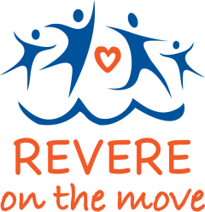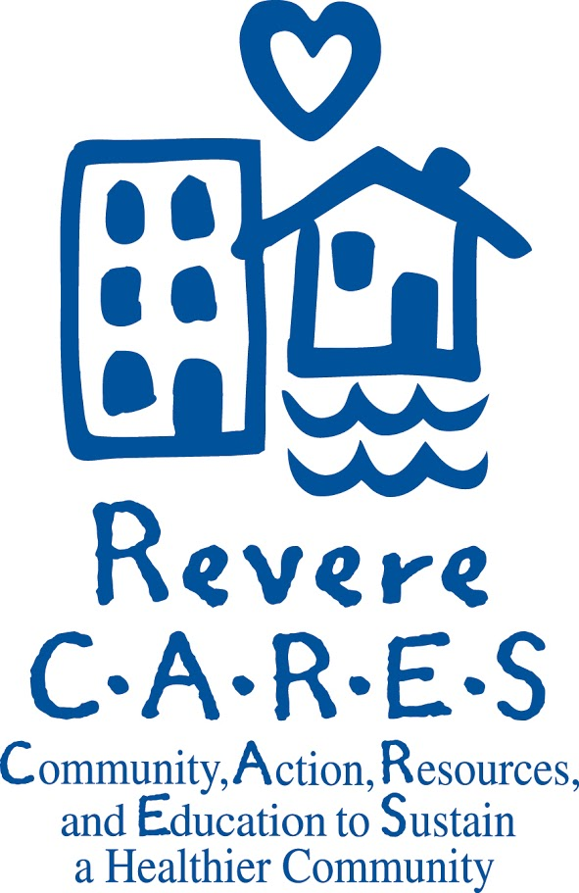

Youth-Led Mini-Grants
Release Date: November, 2016

Due Date: January 8th, 2017 by 11:59pm

Mini Grant Vision:
Our vision for these mini grants is to help Revere be a community where healthy eating and physical activity are a normal part of everyday life. This improves the overall health of our residents.
We aim to make it easy for residents of all ethnic backgrounds and all income levels to afford and access healthy foods in a variety of manners. This includes farmers’ markets, community gardens, engaging school food services, and healthy options at neighborhood restaurants and corner stores.

We also work to make it safe and easy for residents of all ages to be active. Residents should be able to walk and bike across Revere for fun and transportation, be active in schools, and access a network of urban trails and parks that residents are proud of.

Revere on the Move is a Mass in Motion initiative, funded by Partners Healthcare and co-led by the City of Revere and MGH Revere CARES Coalition. We are a community-led initiative working to make healthy eating and active living the easy choice in Revere. We are led by a Task Force that represents our many close partner organizations and dedicated community members.

The goal of the MGH Revere CARES Coalition is to improve the wellbeing of Revere’s residents by preventing substance abuse and promoting healthy eating, active living. We do our work by creating opportunities for residents, organizations, and community leaders to understand what affects the health of residents and partnering to find solutions that make Revere a healthy place for you and your family.

Mini Grant Goal:
Revere on the Move (ROTM) is offering up to $3,000 in mini-grants to support programs or policy, systems, and environmental changes (PSEs) led by youth in the Revere community. Applicants should be 19 years of age or younger and live in the Revere, but do not have to be a student at a school in Revere. Each project should have an adult mentor. Proposed projects must take place in Revere and be completed by the end of 2017 in order to be considered for funding.

We define policy, systems, and environmental changes as permanent changes that can affect the entire community for years to come. Policy changes may be any formal or informal rule, such as changing workplace policies to provide time off during work hours for physical activity. Systems changes address the way things are normally done in an organization such as a school or the transportation system. Environmental changes involve improvements to the physical environment.
We define programs as short-term, possibly even one-time events that serve people at an individual level but do not make permanent changes to the environment or policies. A program would be a walking club on the urban trail for the summer.

Timeline:
Applications are due Sunday, January 8th, 2017 by 11:59pm.
You can expect to hear back from us by February 1st, 2017.

Available Funds:
- In this round, we will be awarding up to $3,000
- You may apply for any amount between $1 and $3,000 as long as the amount is justified. The amount may be negotiated or adjusted by the review committee.
- The Revere Youth Health Leadership Council reviews all proposals, considers the total amount requested, impact, and other proposals and will try to fund as many ideas as possible.

Evaluation Criteria:
The mini-grant applications will be evaluated on the following criteria:

- Level of impact (School/ City/ Neighborhood/ Population Sub-Group)
- Does your proposal meet the goal of supporting Revere youth to live healthier lives?
- Does the applicant show they are able to carry out the proposal? Is the project led by youth?
- Is the budget reasonable?

For more information about how your proposal will be scored, see the rubric at the end of the application.

Reporting Requirement:
- You will also be required to complete a one-page reporting template at the end of the school year. If your project continues beyond June, you will be required to complete another reporting template at the completion of your project.

Let us help you:

- The ROTM Task Force will provide a workshop for at the Revere High School on Wednesday, December 14th. Bring a draft of your proposal and receive one-on-one guidance to help improve your application!
- The ROTM Task Force commits to provide grant winners with timely assistance, including feedback on measures of success and connections to other community members and organizations who might be potential partners. For additional information, please see application for contact information.

Join our Task Force!
- Grant awardees will be invited to attend ROTM Task Force Meetings during the duration of their project. We meet quarterly on the 3rd Thursday of the month from 5:00-6:30pm at the Revere Police Station.

APPLICATION
General Information:
Name of contact person:_____________________________________________
Phone number: ____________________________________________________
Email address:_____________________________________________________
Mailing address: ___________________________________________________
Your neighborhood, school or community affiliation:________________________
Contact info for your adult mentor:
Name: ________________________________________
Email:_________________________________________
Phone:________________________________________

To apply for one of our mini-grants, please offer as much detail as possible. The suggested length is 2-3 pages. Please submit your answers to the following questions online using the Google Form Application or email them to us on a separate, preferably typed document.

Google Form Application can be accessed here: https://goo.gl/forms/AVMbww5g7XN6GCSD2

- Please describe your project/activity/program.

- Why is your project/activity needed?

- What do you hope to accomplish?

- How will the community benefit from your project?

- How many people will your proposal impact? Is your proposal as inclusive as possible of all ethnicities, religions, and abilities?

- How does your proposal advance the vision of Revere on the Move? (see info page)

- Who will be involved and what will their roles be?

- When will your project begin and end? Please provide a detailed timeline.

- Will there be a final, big project or donation?

- How will you promote your efforts and show your results to others in the community?

- What problems or obstacles might make this project difficult? How do you plan to address them?

- Please share how you will request support/permission from school principals or administrators if needed.

- How will you know if your program is successful? What will you measure and how? What specifically will you report back to us at the end of the project?

- Will you seek or use money from other sources to supplement your program? (Note: This will not affect your application, but it gives us a better picture of what your capacity will be)

- Please attach a budget with an explanation of each expense in your budget. (see example on next page)

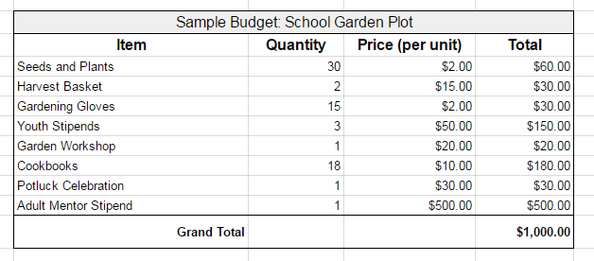

Sample Budget Explanation

Seeds and Plants: In our garden we have space for a total of 30 plants and seeds. We have researched garden stores and found that Home Depot sells the plants and seeds for $2.00 each.

Harvest Baskets: To harvest from our garden plot, we will need baskets. We will purchase 2 food-grade plastic baskets from Whole Foods, each costing $15.00. We will first try to seek a donation of shopping baskets from Whole Foods to save on our budget. Other gardening tools will be needed for our project as well, such as a gardening shovels, trash bags, and a hose and nozzle; however, these tools are already available at the Revere First Community Garden, so we do not need to purchase our own.

Gardening Gloves: We will purchase 15 sets of garden gloves from Home Depot. These will help keep the student gardeners clean and safe.

Youth Stipends: Three youth will be the leaders of this project. They will plan which fruits and vegetables to plant and research how to plant them correctly. Additionally these three youth will organize a workshop where they will teach their peers the basics of gardening. Since we value the time and work of youth, we will pay them a $50 stipend for planning and organizing this project and for leading the workshop.

Garden Workshop: On Friday, March 4th, we will hold our garden workshop. Our budget of $20 is to purchase water and sunscreen for the students attending to make sure everyone stays hydrated and safe from sunburns while we are outside.

Cookbooks: We will purchase the cookbook, Plated, for each of the 15 student gardeners and the three youth leaders (18 books total) so that we can learn to cook the produce we have grown. The cookbook is from Barnes and Noble and costs $15.

Potluck Celebration: After a season of gardening, we want to celebrate our harvest! Students will make recipes from the cookbook and bring them to share at an afterschool party. The budget of $30 is to purchase bottled water to drink and plates and utensils.

Adult Mentor Stipend: Our science teacher, Ms Smith, will be the adult mentor for this project. She will help oversee our planning and development of the garden workshop and monitor our gardening. For her time, she will receive a stipend of $500.

If you have any questions or would like help on your application, please contact:

Andie Janota Dimple Rana
Program Coordinator Manager of Healthy Community Initiatives
MGH Revere CARES Coalition City of Revere
300 Ocean Ave 281 Broadway
Revere, MA 02151 Revere, MA 02151
ajanota@partners.org drana@revere.org
781-485-6132 781-286-8172

